Data locality ensures that all data and metadata stay in one region.

The Dataflow backend exists in a few regions across the globe and can be different from the region in which your workers run.

What metadata is transferred between your project and the regional endpoint? There are regular health checks from the workers, workers requesting a work item and the regional endpoint responding with a work item, the worker item status, and autoscaling events. Unexpected events are also transferred to the regional endpoint. For example, unhandled exceptions in user code, jobs that fail to launch because of permissions, worker item failures,

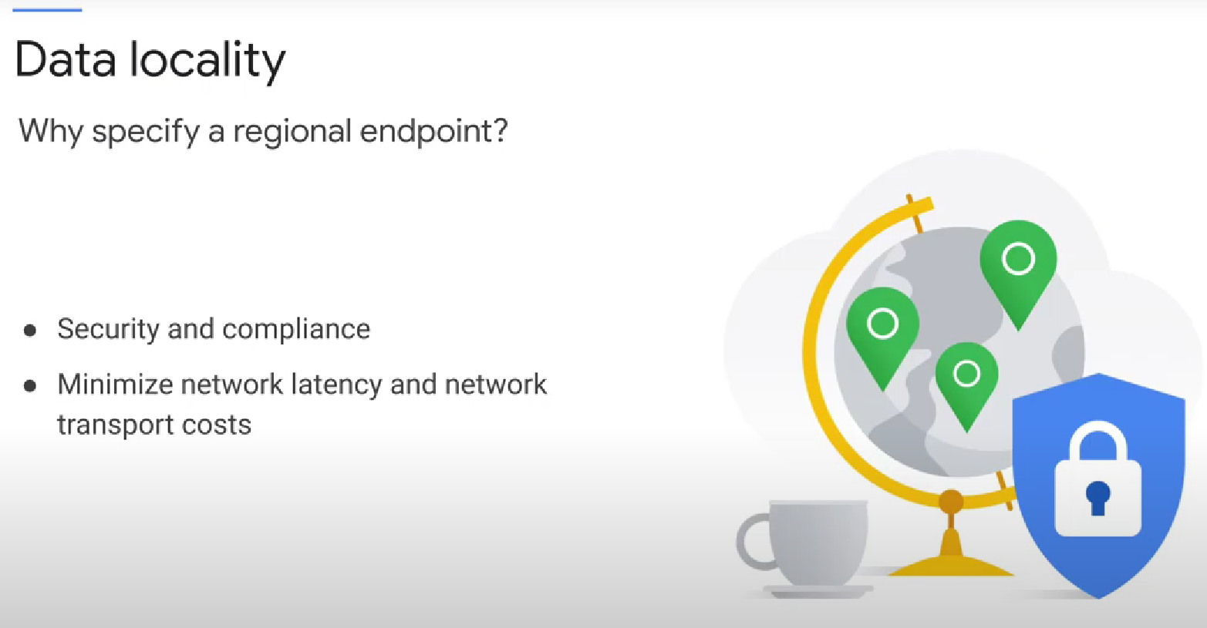

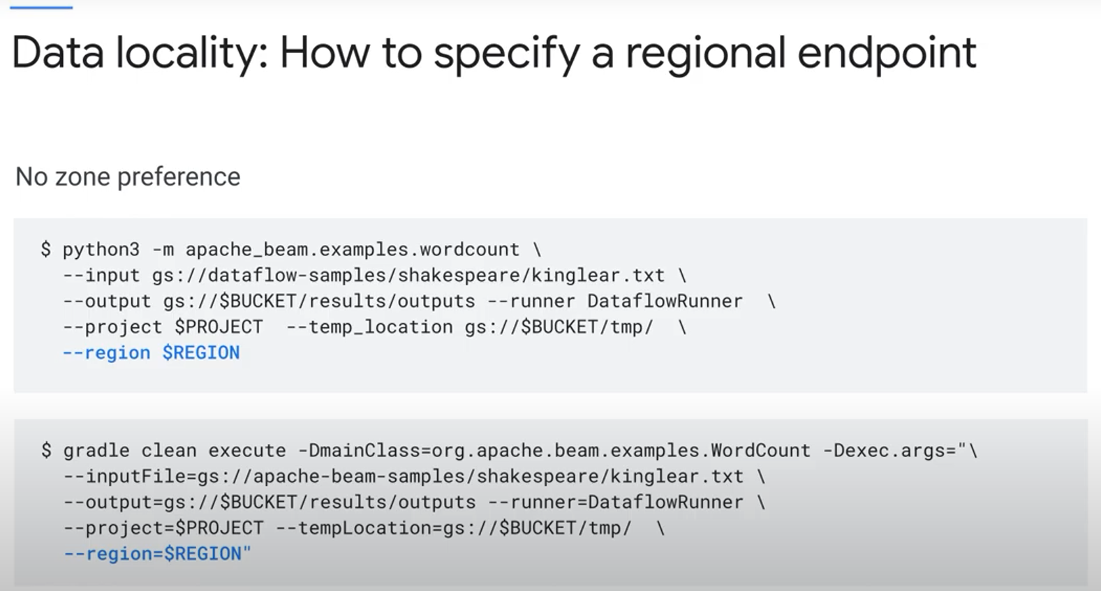

The regional endpoint will automatically select the best zone based on available capacity.

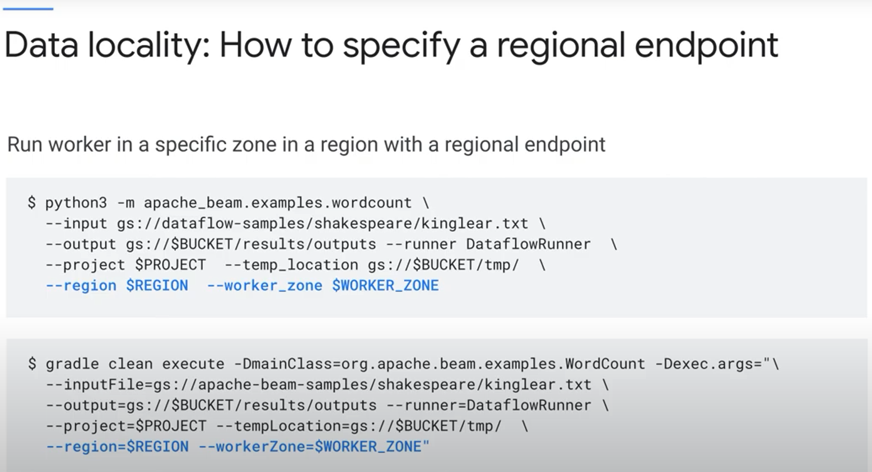

Region: general region

Worker zone: specific region

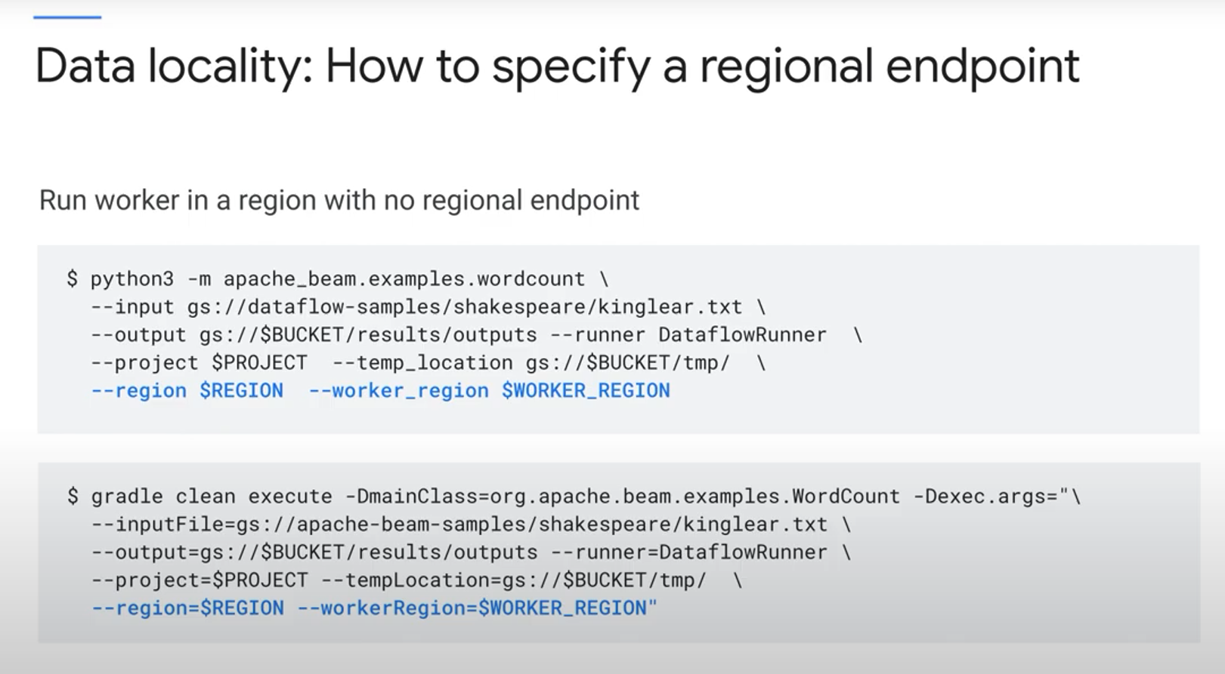

Use the region flag to specify the supported regional endpoint that is **closest** to the region where the worker processing must occur. Use worker region flag to specify THE EXACT region where worker processing must occur, even if there is no regional endpoint in that region.

Note: It is important to note that even if no regional endpoint exists in a region you want your data to be kept in, only metadata is transferred. Your application data stays in that region.

